## SOFTWARE QUALITY ASSURANCE MANAGEMENT

## NAME:S.Logitha

**13.USING RAPTOR – CALCULATE FIBONACCI SERIES**

**FLOW CHART**

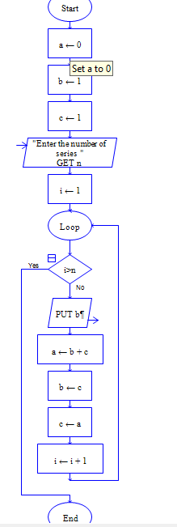

**OUTPUT**

INPUT IS 9

